**FLASK WITH IBM CLOUD OBJECT STORAGE**

● App.py

flask import Flask,redirect,url_for,render_template,request

import ibm_boto3

from ibm_botocore.client import Config, ClientError

COS_ENDPOINT="https://s3.jp-tok.cloud-object-storage.appdomain.cloud" COS_API_KEY_ID=" "

COS_INSTANCE_CRN=""

# Create resource https://s3.ap.cloud-object-storage.appdomain.cloud

cos = ibm_boto3.resource("s3",

ibm_api_key_id=COS_API_KEY_ID, from

ibm_service_instance_id=COS_INSTANCE_CRN,

config=Config(signature_version="oauth"),

endpoint_url=COS_ENDPOINT

)

app=Flask(__name__)

def get_item(bucket_name, item_name):

print("Retrieving item from bucket: {0}, key: {1}".format(bucket_name, item_name)) try:

file = cos.Object(bucket_name, item_name).get()

print("File Contents: {0}".format(file["Body"].read()))

except ClientError as be:

print("CLIENT ERROR: {0}\n".format(be))

except Exception as e:

print("Unable to retrieve file contents: {0}".format(e))

def get_bucket_contents(bucket_name):

print("Retrieving bucket contents from: {0}".format(bucket_name))

try:

files = cos.Bucket(bucket_name).objects.all()

files_names = []

for file in files:

files_names.append(file.key)

print("Item: {0} ({1} bytes).".format(file.key, file.size))

return files_names

except ClientError as be:

print("CLIENT ERROR: {0}\n".format(be))

except Exception as e:

print("Unable to retrieve bucket contents: {0}".format(e))

def delete_item(bucket_name, object_name):

try:

cos.delete_object(Bucket=bucket_name, Key=object_name)

print("Item: {0} deleted!\n".format(object_name))

except ClientError as be:

print("CLIENT ERROR: {0}\n".format(be))

except Exception as e:

print("Unable to delete object: {0}".format(e))

def multi_part_upload(bucket_name, item_name, file_path):

try:

print("Starting file transfer for {0} to bucket: {1}\n".format(item_name, bucket_name)) # set 5 MB chunks

part_size = 1024 * 1024 * 5

# set threadhold to 15 MB

file_threshold = 1024 * 1024 * 15

# set the transfer threshold and chunk size

transfer_config = ibm_boto3.s3.transfer.TransferConfig(

multipart_threshold=file_threshold,

multipart_chunksize=part_size

)

# the upload_fileobj method will automatically execute a multi-part upload

# in 5 MB chunks for all files over 15 MB

with open(file_path, "rb") as file_data:

cos.Object(bucket_name, item_name).upload_fileobj( Fileobj=file_data,

Config=transfer_config

)

print("Transfer for {0} Complete!\n".format(item_name)) except ClientError as be:

print("CLIENT ERROR: {0}\n".format(be))

except Exception as e:

print("Unable to complete multi-part upload: {0}".format(e))

@app.route('/')

def index():

files = get_bucket_contents('flaskapp123')

return render_template('index.html', files = files)

@app.route('/deletefile', methods = ['GET', 'POST'])

def deletefile():

if request.method == 'POST':

bucket=request.form['bucket']

name_file=request.form['filename']

delete_item(bucket,name_file)

return 'file deleted successfully'

if request.method == 'GET':

return render_template('delete.html')

@app.route('/uploader', methods = ['GET', 'POST'])

def upload():

if request.method == 'POST':

bucket=request.form['bucket']

name_file=request.form['filename']

f = request.files['file']

multi_part_upload(bucket,name_file,f.filename)

return 'file uploaded successfully <a href="/">GO to Home</a>'

if request.method == 'GET':

return render_template('upload.html')

if __name__=='__main__':

app.run(host='0.0.0.0',port=8080,debug=True)

● DELETE.html

<html>

<body>

<a href="/">HOME</a>

<a href="/uploader">Upload </a>

<a href="/deletefile">Delete </a>

<br><hr>

<h1>IBM Object Storage</h1>

<form action = "/deletefile" method = "POST" >

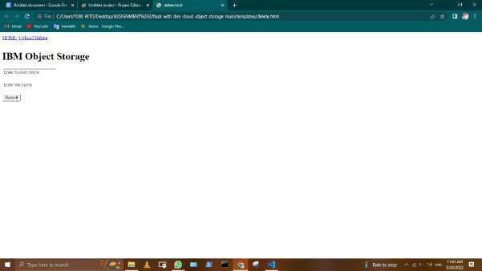

● INDEX.HTML

<a href="/">HOME</a>

<a href="/uploader">Upload</a>

<a href="/deletefile">Delete</a>

<br><hr>

<h1>IBM Object Storage</h1>

<!doctype html>

<html>

<body>

<div style="border: 1px solid #EFEFEF;margin:10px;">

<h3>Filename : {YUKI RITO} </h3>

<img src="https://flaskapp123.s3.jp-tok.cloud-object-storage.appdomain.cloud/{{row}}" width="150px"></td>

</div>

</body>

</html>

IMAGE:

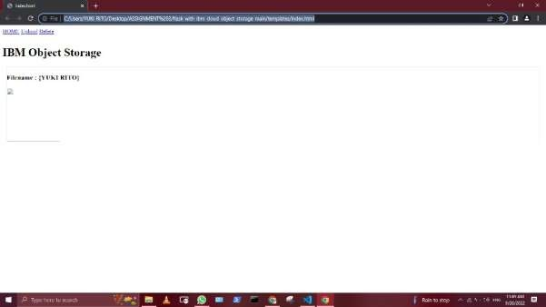

● UPLOAD .HTML

<html>

<body>

<a href="/">HOME</a>

<a href="/uploader">Upload </a>

<a href="/deletefile">Delete </a>

<br><hr>

<h1>IBM Upload File</h1>

<form action = "/uploader" method = "POST"

enctype = "multipart/form-data">

<input type = "text" placeholder="Enter bucket name" name = "bucket" />

<br>

<br>

<input type = "text" placeholder="Enter file name" name = "filename" />

<br>

<br>

<input type = "file" name = "file" />

<br>

<br>

<input type = "submit"/>

</form>

</body>

</html>

